# Example of using a systematic creativity method

[Note: all of these things already exist. This is just an example to show how this method could have been applied to identify these new ideas.]

## Object: treadmill

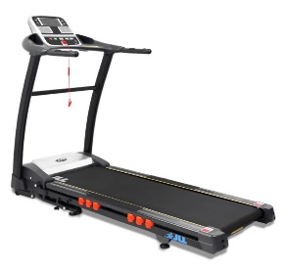

Elements (not exhaustive)

Belt, rollers, cushioning, baseboard, start button, stop button, speed, incline motor, arms, screen, heart rate sensors, safety harness, fitness, leisure, gym.

## Use a systematic creativity method to create something new

### Example 1

1. Remove the arms (Solve X by removing an Element)
2. Remove the screen (Solve X by removing an Element)
3. Reduce the maximum speed (Solve X by removing (some of) an Element)
4. Change the context to work, not gym (Solve X by skewing an Element)

Result: Standing treadmill desk



### Example 2

1. Remove the screen (Solve X by removing an Element)
2. Move the position of the safety harness to overhead (Solve X by creating an imbalance between two Elements?)
3. Shorten the length of the harness (Solve X by removing (some of) an Element)
4. Change the end user from humans to pets (Solve X by skewing an Element)

Result: dog treadmill

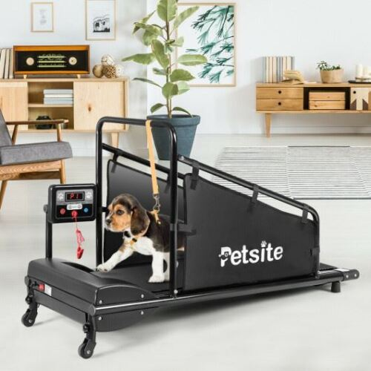

### Example 3

1. Remove the screen (Solve X by removing an Element)
2. Remove the safety harness (Solve X by removing an Element)
3. Increase the length of the base board (Solve X by adding more of an Element)
4. Increase the length of the belt (Solve X by adding more of an Element)
5. Increase the width of the belt (Solve X by adding more of an Element)
6. Remove the incline motor (Solve X by removing an Element)
7. Remove ability to alter speed (Solve X by removing an Element)
8. Change the context from fitness to transportation (Solve X by skewing an Element)

Result: airport walkway

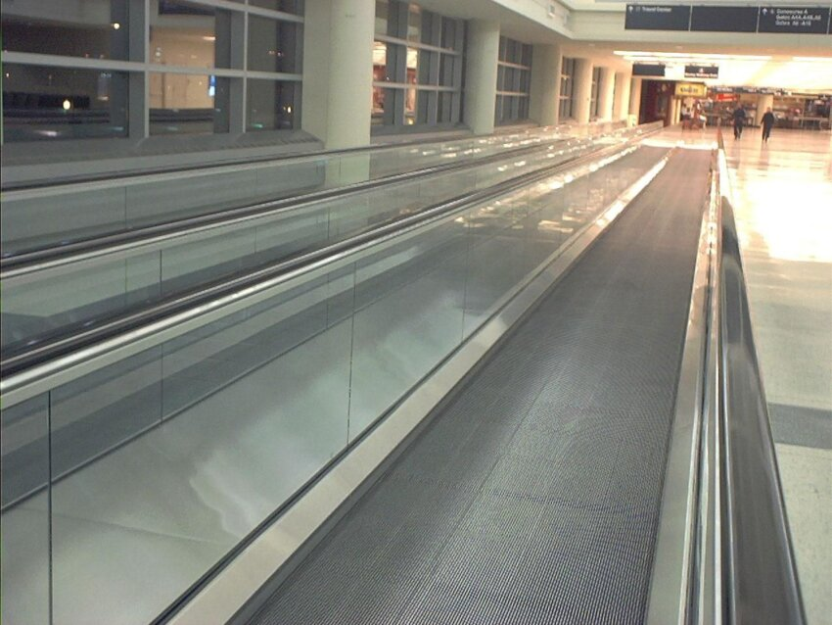

### Example 4

1. Add more cushioning underneath the belt (Solve X by adding more of an Element)
2. Increase the length of the base board (Solve X by adding more of an Element)
3. Increase the length of the belt (Solve X by adding more of an Element)
4. Increase the width of the belt (Solve X by adding more of an Element)
5. Remove the screen (Solve X by removing an Element)
6. Move the position of the safety harness to overhead (Solve X by creating an imbalance between two Elements?)

Result: Cross Country Skiing Treadmill

